Document Authorization:

 | Name | Date | Signature
Owner | David A Macias | 11Dec18 | See Signature on File
Operation Management | Xibo Li | 11Dec18 | See Signature on File
Quality Assurance | Stacey Kaufusi | 11Dec18 | See Signature on File

Changes from previous version:

Section | Summary of Changes | Change Control Number
All | New document initiation for the Therapeutic GMP Manufacturing Suite and Analytical Testing Lab in Petaluma, CA | PCC17001

- PURPOSE
This document provides an overview of how to use an airborne particle counter to collect airborne particulate data.

- SCOPE
This SOP applies to the operation of all particle counters by Therapeutic personnel inside the GMP manufacturing suite in Petaluma, CA.

- INTERNAL REFERENCES
Document ID | Title
PPOL001 (208849) | Quality Policy
PSOP002 (208813) | Good Documentation Practices
PSOP126 (208941) | Environmental Monitoring of the Therapeutic GMP Suite
PFRM021 (208868) | General Equipment Use Log

- EXTERNAL REFERENCES
Document ID | Title
ICH Q7 (API) | Good Manufacturing Practice Guidance for Active Pharmaceutical Ingredients
ICH Q9 | Quality Risk Management
ICH Q10 | Pharmaceutical Quality System
ISO 14644-1 | Cleanrooms and Associated Controlled Environments
ISO 21501-4 | Determination of Particle Size Distribution
DOC026.97.80271 | Beckman Coulter MET ONE HHPC 3+ User Manual

- RESPONSIBILITIES
Job Function and/or Department | Responsibility
Operational Employees | Employees who utilize an airborne particle counter are responsible for adhering to this procedure.
Operational Management | Responsible for verifying the proper usage of an airborne particle counter, as well as, reviewing the acquired data.

- DEFINITION
Term | Definition
cGMP | Current Good Manufacturing Practices
Particles | Airborne matter that is potentially harmful to products
HHPC | Hand-Held Particle Counter

- PROCEDURE
  - Functional verification
    - Turn on the hand-held particle counter (HHPC) by pressing the “Power Button”. See FIGURE 1 below for button layout.
    - Wait to see if the device is at least ½ battery capacity, if it is not, recharge the HHPC to at least ½ battery capacity using the accompanying USB cable for charging the device. See FIGURE 3 for location of battery energy icon.
    - Use the “Menu button” to access the main menu. This is also where the sub-menus can be found.
    - Check to see if enough space is available on the HHPC to store the data that is to be collected, 5,000 data records are available. If the data storage is full and the data is already backed up, then an instrument “Purge” is required, refer to document “DOC026.97.80271” page 13 on how to purge data.
FIGURE 1: BECKMAN COULTER HAND-HELD PARTICLE COUNTER 3+, KEYPAD AND DISPLAY.

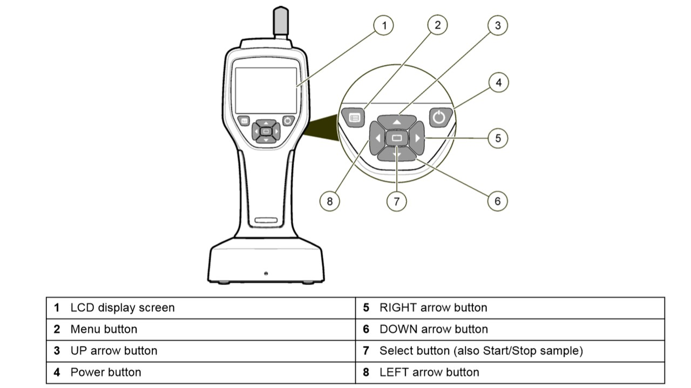
  - Calibration
    - Remove the “Sample inlet protective cap” and attach the “Filter adapter” and “Zero-Count Filter” The filter is in the correct orientation when the green arrow that is on the filter is pointing toward the HHPC. See FIGURE 2 for an illustration.
      - Calibration should take place in the room/suite/environment where the particulate data collection is to occur.
    - Press the “Menu Button” to access the main menu.
FIGURE 2: HHPC 3+ ILLUSTRATION OF CALIBRATION SET-UP AND PARTS
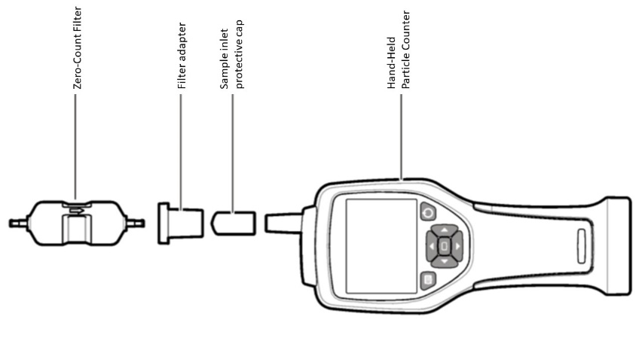

    - Select the “Cal” room-option on the LCD display screen, this is the calibration preprogramed option. It is located on the far right of the room menu. See FIGURE 3 for details; use the left and right arrow buttons to switch between “Rooms” and “Cal” options.

FIGURE 3: ROOM LOCATION VERIFICATION ON HHPC DISPLAY (SOLID RED-BOX). BATTERY CHARGE STATUS ON HHPC DISPLAY (DASHED RED-BOX).
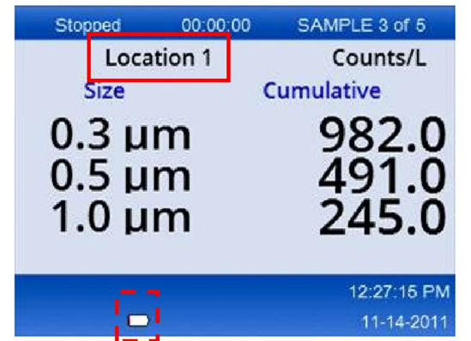
    - Press the “Select” button to start or stop product sampling. The collection process will last for 10 minutes.
      - There is a high, mid, and low 3-dimensional level in each room. Data collection must be distributed between each level.
      - Calibration will last for 10 minutes distributed among two
5-minute blocks.
      - An estimate of air volume tested appears on screen and measures in litres. The HHPC will evaluate 14.16 L per
5 minutes.
      - HHPC is ready to use if NMT 1 particle >0.3 µm are detected in 5 minutes. Compare results with previous results, they should align with slight variation.
    - Use the up-and-down arrows to scroll between rooms and use the
left-and-right arrows to activate and deactivate the “delete data” icon.
  - Particle Counting
    - Take the HHPC into the GMP suite/room/environment.
    - On the HHPC select the specific room to collect data, use the LCD-display screen and arrow buttons to navigate the menu. See FIGURE 3 as to where the location is displayed on the LCD display screen.
    - Start the data collection. Use the method described in 7.2.3 thru 7.2.4 but instead, select the room you would like to collect data on and not the “Cal” option/room/pre-program.
      - To create a new room file, use document “DOC026.97.80271” as a reference.
    - For the Biosafety Cabinet (BSC), clean the HHPC, be careful not to moisten the probe inlet, and place it upright in the centre of the BSC.
    - Start the data collection. See FIGURE 3 for an example of what collected data will resemble. Locations are defined in PSOP126 (208941), Environmental Monitoring of the Therapeutic GMP Suite.
  - Data Extraction
    - When the data has been collected for each room and BSC, upload the data to a computer by plugging the HHPC into a USB port. Use file path: (Y:)/EM/Particulate Counts.
      - The USB connect port is located on the bottom of the HHPC.
    - Click on HHPC USB to open the HHPC data folder. A “locked-for editing” spreadsheet will open.
    - Right click on the desired “data” file and click “copy”.
    - Paste the data file in the desired folder.
    - Rename the file using date format DDMMMYYYY.
      - The file is read only, xls or xlsx format, to comply with CFR 21 Part 11 secure. This can be changed in the “Communication Setup” menu on the HHPC.
  - Data Analysis
    - Open the “Particle Count Trend Data” file.
    - Click to add a new tab and rename it for the date the particle count was done, DDMMMYYYY.
    - Copy and paste the raw data. Make sure that the file is xls, or xlsx format. See 7.4.5.1 for more details.
    - Copy and paste the calculated data from a previous date tab.
    - Copy and paste the results into the appropriate graph by room in the “Trends” tab.
    - Analyse the particle count levels and confirm that none are above the classification limits. See TABLE 1 for allowable particulates.

TABLE 1: CLEANROOM STANDARDS FOR ALLOWABLE PARTICULATES
ISO 14644-1 Cleanroom Standards
 | Maximum particles/m^3
Class | ≥0.3 µm | ≥0.5 µm | ≥1.0 µm
ISO 5 | 10,200 | 3,520 | 832
ISO 6 | 102,000 | 35,200 | 8,320
ISO 7 | 1,020,000 | 352,000 | 83,200
ISO 8 | 1,020,000,000 | 3,520,000 | 832,000

      - The HHPC is set to acquire particle counts for >0.3 µm, >0.5 µm, and >1.0 µm.
      - >0.3 µm is pre-set in the HHPC and cannot be changed.
      - The other two particle sizes are customizable and optional with sizes selectable from 0.5, 1.0, 2.0, 5.0, or 10.0 µm.

